**Renewable Energy and the Environmental Impact of HVAC**

Heating and cooling energy consumption accounts for approximately 50 percent of energy consumption in the average home. With such a substantial energy spend, it’s no wonder that HVAC has a significant environmental impact. HVAC manufacturers are tackling our industry’s environmental impact, starting at the beginning of the line – the manufacturing process – while creating more sustainable products for end users.

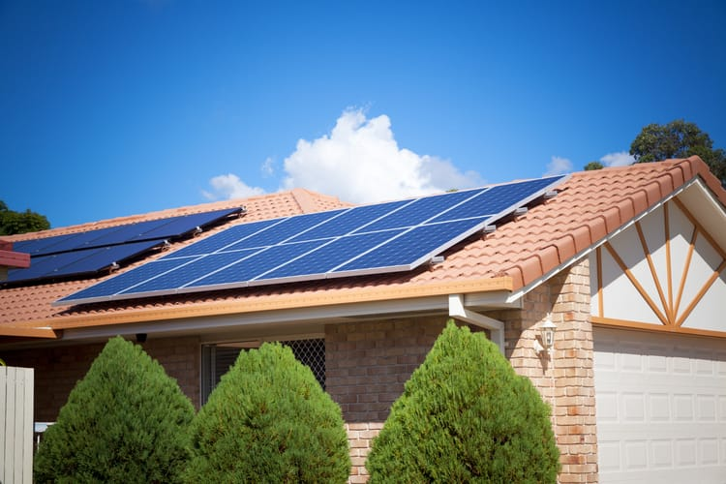

**Johnson Controls Lowers Environmental Impact**

Just last month, HVAC manufacturer [Johnson Controls](https://www.achrnews.com/articles/140322-johnson-controls-hvac-manufacturing-plant-to-operate-on-100-percent-green-energy" \t "/Users/macbookpro/Documents\\x/_blank), announced it’s moving one of its largest facilities to wind power, doing away with conventional electricity. Johnson Controls’ plant in Wichita, Kansas produces components for popular heating and cooling brands including:

York

Luxaire

Coleman

Champion

With this switch, the plant will reduce its environmental impact, creating zero emissions from electricity. This major move lowers the brand’s greenhouse gas emissions in North America by 18 percent! The wind farm is scheduled to be completed and in service for the plant by the end of the year. The projected energy savings for the 20-year contract will equal around $2.7 million.

Johnson Controls is no stranger to sustainability efforts. The company has a Corporate Sustainability Team and has been working to lessen the brand’s environmental impact since 2002. Over this time, they’ve cut greenhouse gas emissions by 50 percent across their global operations, and lowered U.S. manufacturing energy consumption by 25 percent.

**New HVAC Technology Lessens Environmental Impact**

HVAC manufacturers’ commitment to limiting negative environmental impact not only shows in their manufacturing processes, but in the products they build. Renewable energy use is becoming more widespread in heating and cooling products for end users. HVAC products that harness renewable energy include:

Geothermal Heat Pumps: While not a new technology, the use of geothermal HVAC is growing across the country. These systems use the natural energy stored below ground for indoor space heating and cooling.

Ice-Powered Air Conditioning: New ice-powered cooling systems create home cooling through the use of renewable thermal batteries. These systems create ice in off-peak times, storing it for future cooling. Peak cooling electricity costs can be lowered an astounding 95 percent for up to 6 hours a day.

Solar HVAC: Solar energy is used to power heating and cooling systems in addition to lighting systems and other appliances throughout the home.

**How Renewable Energy HVAC Lowers Environmental Impact**

How does the use of such technology lessen the environmental impact of heating and cooling? Lowering non-renewable energy consumption directly lowers harmful emissions. New products are using environmentally safe refrigerants to protect our ozone layer.

Burning fossil fuels for gas heating and even in the generation of electricity for electric heating and cooling produces greenhouse gases. Greenhouse gases are directly tied to the rising temperatures worldwide. Switching to renewable energy for HVAC systems significantly lowers or even eliminates greenhouse gas emissions.

The use of Freon (R-22) has been banned for newly manufactured HVAC equipment, and the industry has largely switched to Puron, or R-410A. This alternative is not a hydrochlorofluorocarbon (HCFC), and does not damage the ozone layer. Freon is being phased out through 2020 per the Montreal Protocol.

From:https://www.hvac.com/blog/renewable-energy-and-the-environmental-impact-of-hvac/